9. Develop neural network-based time series forecasting model
AIM:
To Develop a neural network based time series forecasting using autism dataset
PROCEDURE:
1.Import the necessary libraries:
import pandas as pd
import numpy as np
import matplotlib.pyplot as plt
from sklearn.preprocessing import MinMaxScaler
from tensorflow.keras.models import Sequential
from tensorflow.keras.layers import LSTM, Dense
from sklearn.model_selection import train_test_split
from pandas.plotting import register_matplotlib_converters
register_matplotlib_converters()
2.Load dataset
file_path = 'autism_screening.csv' # Update the filename if needed
df = pd.read_csv(file_path)
3.Simulate a time-series index (assuming daily records)
df['Date'] = pd.date_range(start='2024-01-01', periods=len(df), freq='D')
df.set_index('Date', inplace=True)
4. Check for and handle zero/negative values
if (series <= 0).any():
min_value = series.min()# Shift the series to be positive
if min_value <= 0:
series = series + abs(min_value) + 1 # Add 1 to ensure all values are strictly positive

5. Visualize the data
monthly_positive.plot(title="Monthly Positive Autism Screenings")
plt.xlabel("Month")
plt.ylabel("Number of Positive Screenings")
plt.show()
6. Prepare the data for LSTM
scaler = MinMaxScaler(feature_range=(0, 1))
scaled_data = scaler.fit_transform(monthly_positive.values.reshape(-1, 1))
def create_dataset(data, time_step=1):
X, y = [], []
for i in range(len(data) - time_step - 1):
X.append(data[i:(i + time_step), 0])
y.append(data[i + time_step, 0])
return np.array(X), np.array(y)
X, y = create_dataset(scaled_data, time_step)
X = X.reshape(X.shape[0], X.shape[1], 1)

7. Split the data into training and testing sets
X_train, X_test, y_train, y_test = train_test_split(X, y, test_size=0.2, shuffle=False)
8. Build the LSTM model04
model = Sequential()
model.add(LSTM(units=50, return_sequences=True, input_shape=(time_step, 1)))
model.add(LSTM(units=50, return_sequences=False))
model.add(Dense(units=1))
9. Compile and train the model
model.compile(optimizer='adam', loss='mean_squared_error')
history = model.fit(X_train, y_train, epochs=20, batch_size=32, validation_data=(X_test, y_test))
10. Plot training & validation loss
plt.plot(history.history['loss'], label='train')
plt.plot(history.history['val_loss'], label='test')
plt.title("Model Loss")
plt.xlabel('Epochs')
plt.ylabel('Loss')
plt.legend()
plt.show()
11. Plot the actual vs predicted values
plt.figure(figsize=(10, 6))
plt.plot(y_test_actual, color='blue', label="Actual Positive Screenings")
plt.plot(predictions, color='red', label="Predicted Positive Screenings")
plt.title("Actual vs Predicted Positive Screenings")
plt.xlabel("Month")
plt.ylabel("Number of Positive Screenings")
plt.legend()
plt.show()
OUTPUT :
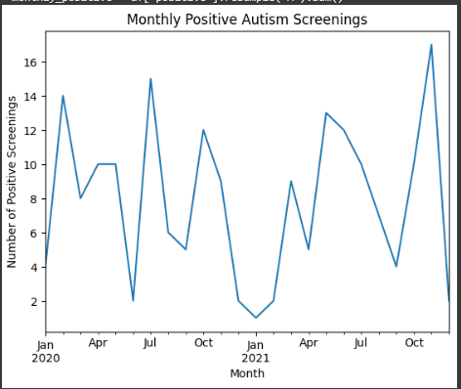

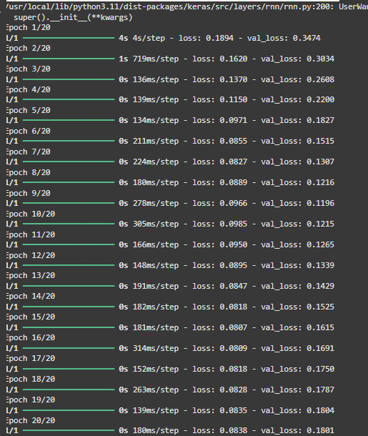
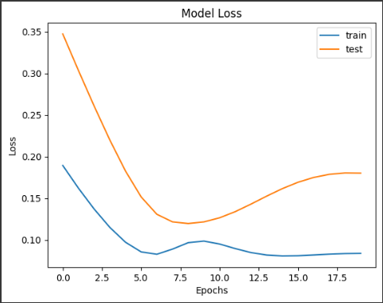

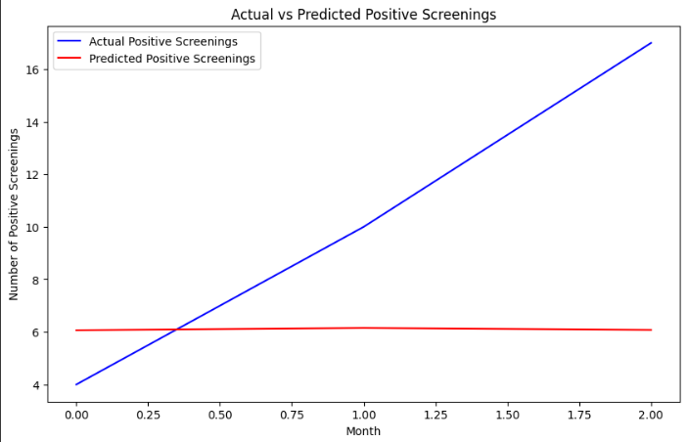

RESULT:
To Develop a neural network based time series forecasting(LSTM) using autism dataset on the autism screening dataset has been implemented successfully.

